**Adding a User**

Adding users to the properties files is the primary purpose of this utility.

|  |  |
| --- | --- |
| https://docs.jboss.org/author/images/icons/emoticons/warning.gif | The server caches the contents of the properties files in memory, however the server does check  the modified time of the properties files on each authentication request and re-load if the time  has been updated - this means all changes made by this utility are immediately applied to any  running server. |

**A Management User**

|  |  |
| --- | --- |
| https://docs.jboss.org/author/images/icons/emoticons/warning.gif | The default name of the realm for management users is ManagementRealm, when the utility  prompts for the realm name just accept the default unless you have switched to a different realm. |

**Interactive Mode**

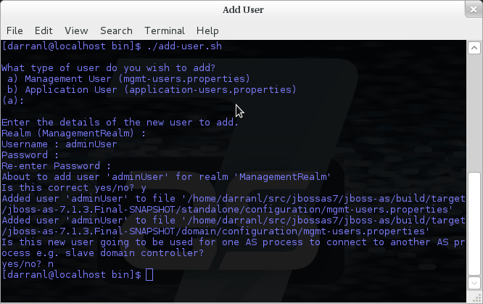

Here we have added a new Management User called adminUser, as you can see some of the questions offer default responses so you can just press enter without repeating the default value.

**Non-Interactive Mode**

To add a user in non-interactive mode the command ./add-user.sh {username} {password} can be used.

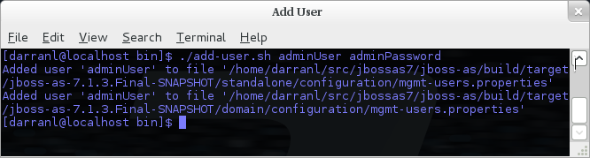

|  |  |
| --- | --- |
| https://docs.jboss.org/author/images/icons/emoticons/forbidden.gif | If you add users using this approach there is a risk that any other user that can view the  list of running process may see the arguments including the password of the user being added,  there is also the risk that the username / password combination will be cached in the history  file of the shell you are currently using. |

**An Application User**

When adding application users in addition to adding the user with their pre-hashed password it is also now possible to define the roles of the user.

**Interactive Mode**

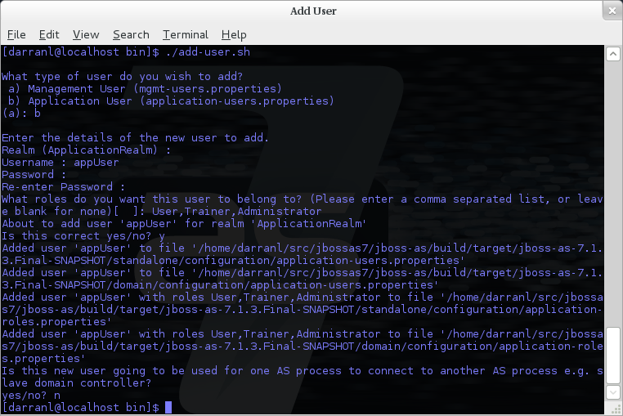

Here a new user called appUser has been added, in this case a comma separated list of roles has also been specified.

As with adding a management user just answer n or no to the final question until you know you are adding a user that will be establishing a connection from one server to another.

**Non-Interactive Mode**

To add an application user non-interactively use the command ./add-user.sh -a {username} {password}.

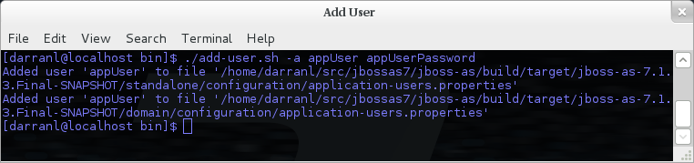

|  |  |
| --- | --- |
| https://docs.jboss.org/author/images/icons/emoticons/warning.gif | Non-interactive mode does not support defining a list of users, to associate a user with a set of roles you will need to manually edit the application-roles.properties file by hand. |

**Updating a User**

Within the add-user utility it is also possible to update existing users, in interactive mode you will be prompted to confirm if this is your intention.

**A Management User**

**Interactive Mode**

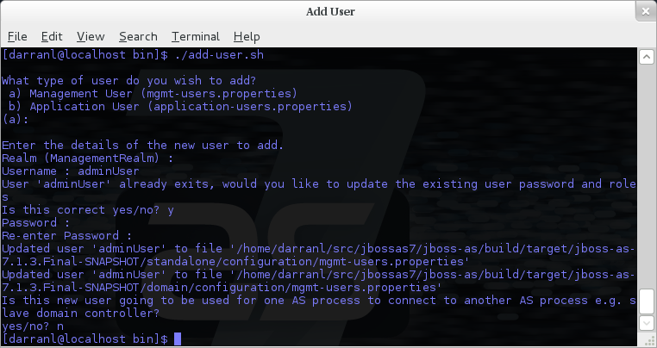

**Non-Interactive Mode**

In non-interactive mode if a user already exists the update is automatic with no confirmation prompt.

**An Application User**

**Interactive Mode**

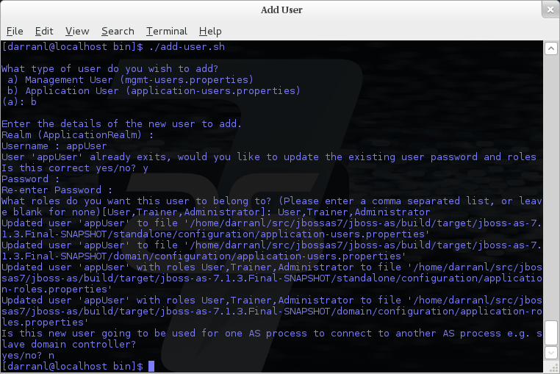

|  |  |
| --- | --- |
| https://docs.jboss.org/author/images/icons/emoticons/warning.gif | On updating a user with roles you will need to re-enter the list of roles assigned to the user. |

**Non-Interactive Mode**

In non-interactive mode if a user already exists the update is automatic with no confirmation prompt.

**Community Contributions**

There are still a few features to add to the add-user utility such as removing users or adding application users with roles in non-interactive mode, if you are interested in contributing to JBoss AS development the add-user utility is a good place to start as it is a stand alone utility, however it is a part of the AS build so you can become familiar with the AS development processes without needing to delve straight into the internals of the application server.